Warner bros re-DESIGN PROCESS

Table of Contents

1.Website Specifications_______________________________________________________

2. Information Design & Taxonomy______________________________________________

3. Page Template Design_______________________________________________________

4. Technical Brief____________________________________________________________

5. Quality Assurance__________________________________________________________

6. Publishing & Promotion_____________________________________________________

7. Future Developments/Recommendations________________________________________

1.Website Specification

INRODUCTION

This documentation serves as a guide to how I re-designed the Warner-Bros movie website from planning to designing and development of the website. This document contains all the necessary steps required to make a successful website

OBJECTIVES AND GOALS OF THE WEBSITE

* To present the audience with an easy, quick, and clear navigation for the website's content.
* To give the audience the latest news in the entertainment industry.
* Search engine for ease navigation.
* Increase profits for the company through the streams.
* Expand the business.
* Gain a new source of income through potential investors.

TARGET AUDIENCE

The youth around the age of 18 to 35 as they are the ones who mostly saturate the internet looking for new ways to enlighten their horizons as well as find something to ease their boredom.

BUSINESS REQUIREMENTS

The Speech from the founder of the company welcome the audience to the website.

The search bar so the audience can navigate easily through the website.

The login and signup form so that the company can keep track of the audience as well as provide the with the latest news concerning the website.

The ratings form so that the audience can evaluate their experience throughout the website.

Comments and reviews so that the audience can state the likes and dislikes about the website thus providing the company with ways to improve it

2.Information design & taxonomy

SITEMAP

A sitemap is a hierarchical structure and flow of a website, outlining the relationships between different pages or sections by illustrating the navigation flow and the relationships between different sections of the website. It helps the users to understand and access the content and structure of a website as well as provide information about the importance and details of the website as well as files included in it.

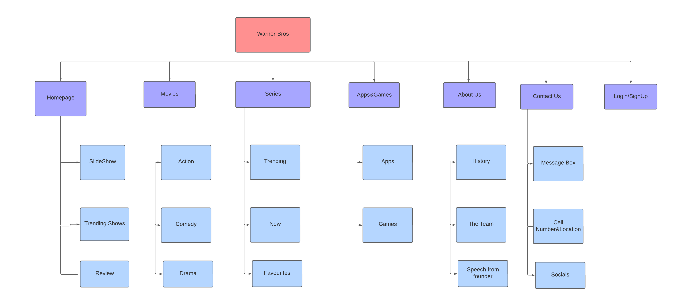

Homepage: compels the audience to dig deeper into the website whilst facilitating an easy navigation through the website whilst providing links to the information that then audience really requires. It should also be visually striking, ideal in a colour to calm the audience.

Movies: Provides the audience with a wide variety of shows that interest the users

Series: Provides the audience with a wide variety of shows that interest the users

Apps & Games: provides the audience with different ways to have fun while browsing through the website/

About Us: introduces the company to the audience and builds trust with them whilst drawing in potential customers and investors

Contact Us: shows the comments and reviews from previous customers and their opinion on the website.

Login and sign up- form: should provide a smooth login experience that can draw in audiences to onto the site without friction.

3.Page Template design

**Homepage wireframe**

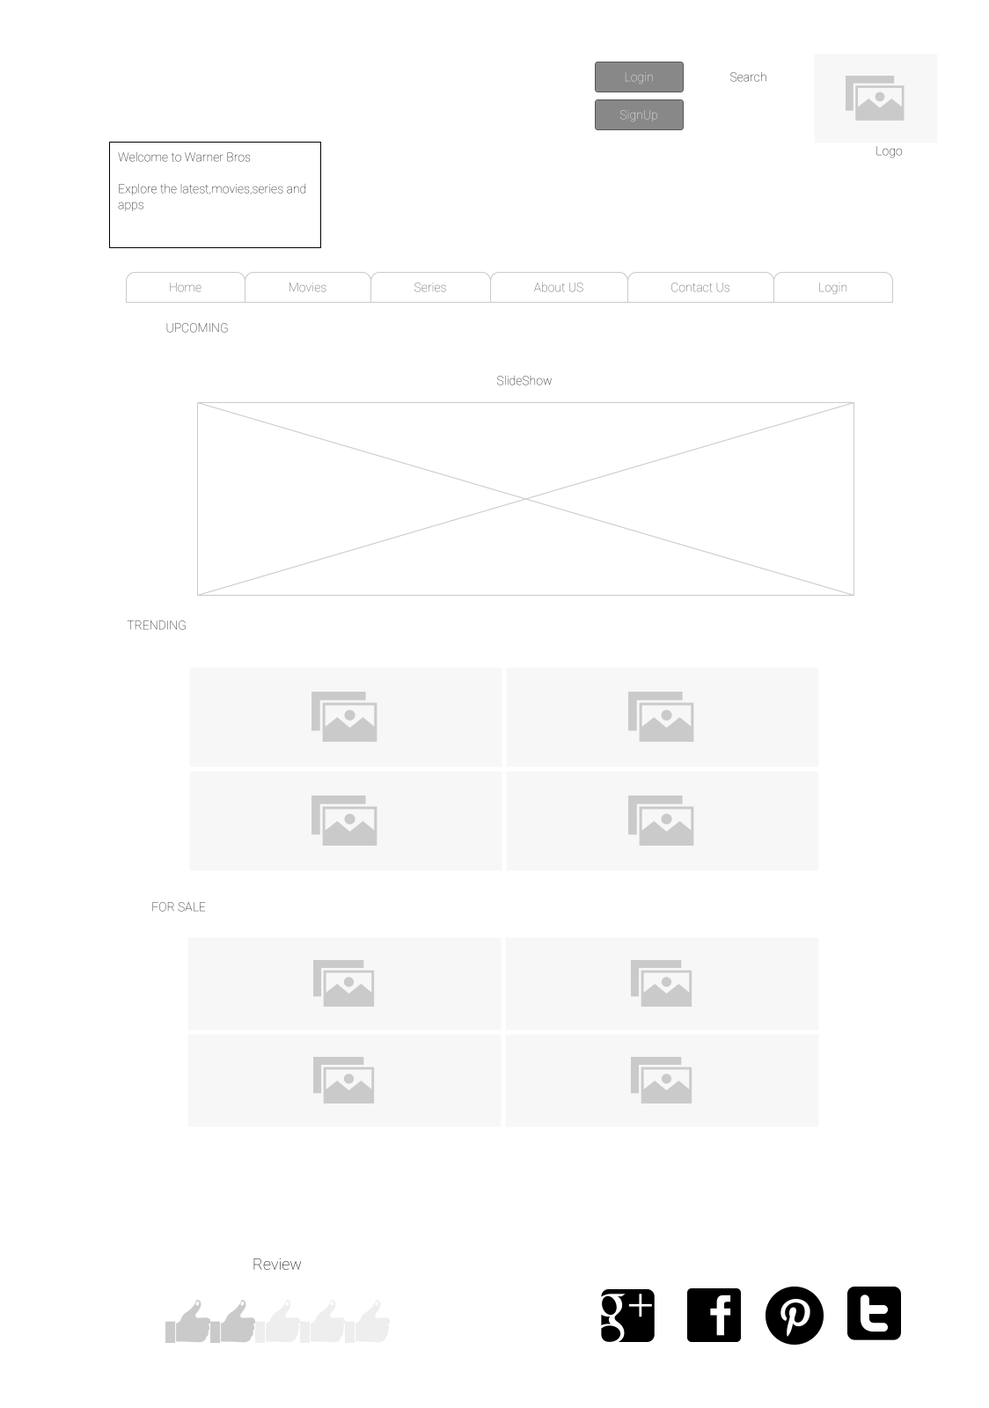

**Movie page wireframe**

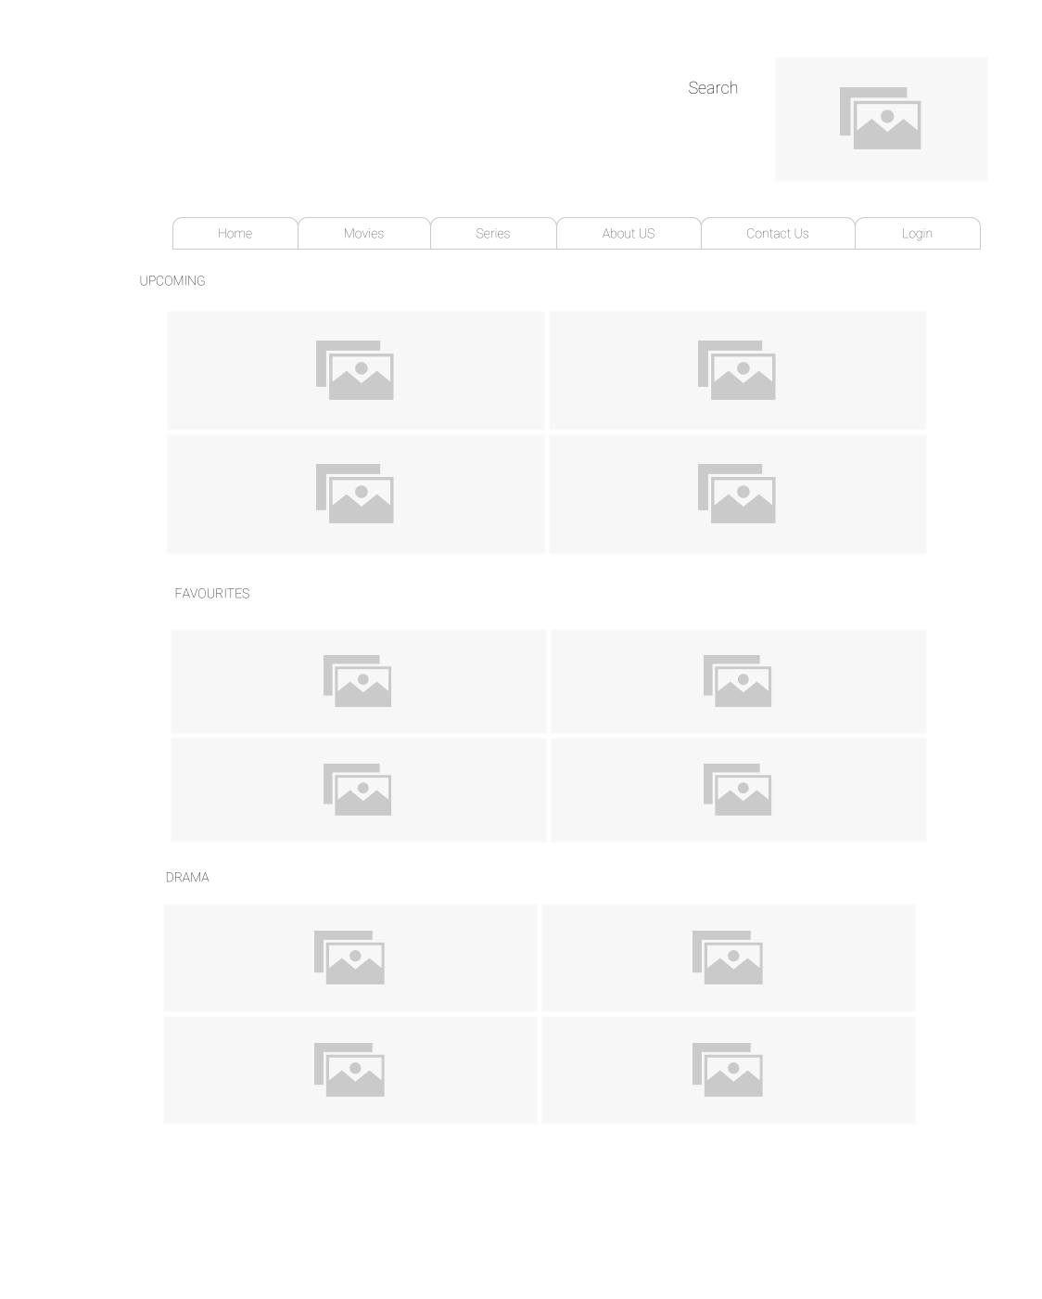

**Series page wireframe**

**Apps & Games wireframe**

**About Us wireframe**

**Contact Us wireframe**

4.Technical Brief

The website was created using HTML5, CSS and JavaScript . The aim of this is to enhance the user experience, modernize the design, improve performance, and ensure cross-platform compatibility. The redesign should align with Warner Bros' branding guidelines and incorporate the latest web technologies and best practices. The code was mainly written using VS code which made sure that the website has cross-browser compatibility. Lastly the was gimp which is a free and open-source graphics editor used for image manipulation and editing images.

5.Quality Assurance

The website was run across multiple browser to check if they function consistently and effectively across the browsers. Thorough testing is conducted to identify and address any compatibility issues, ensuring a seamless user experience and the only problem we had was mobile testing.

* .**Microsoft Edge**

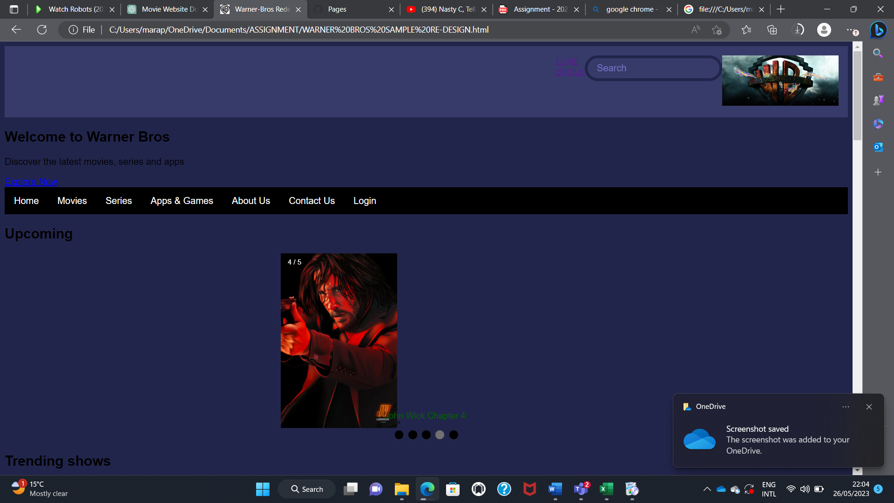

* **Google Chrome**

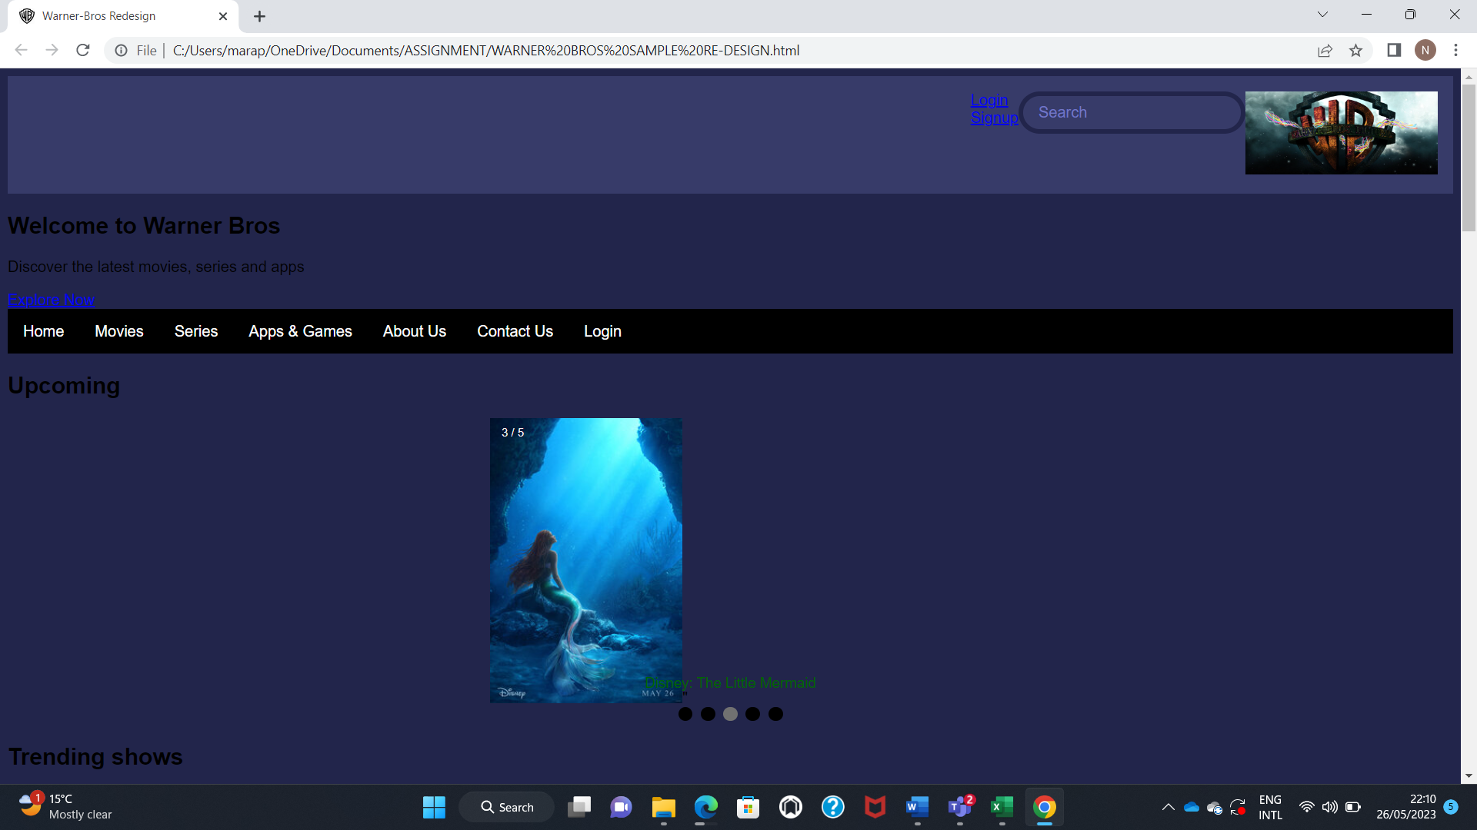

* **Modzilla Firefox**

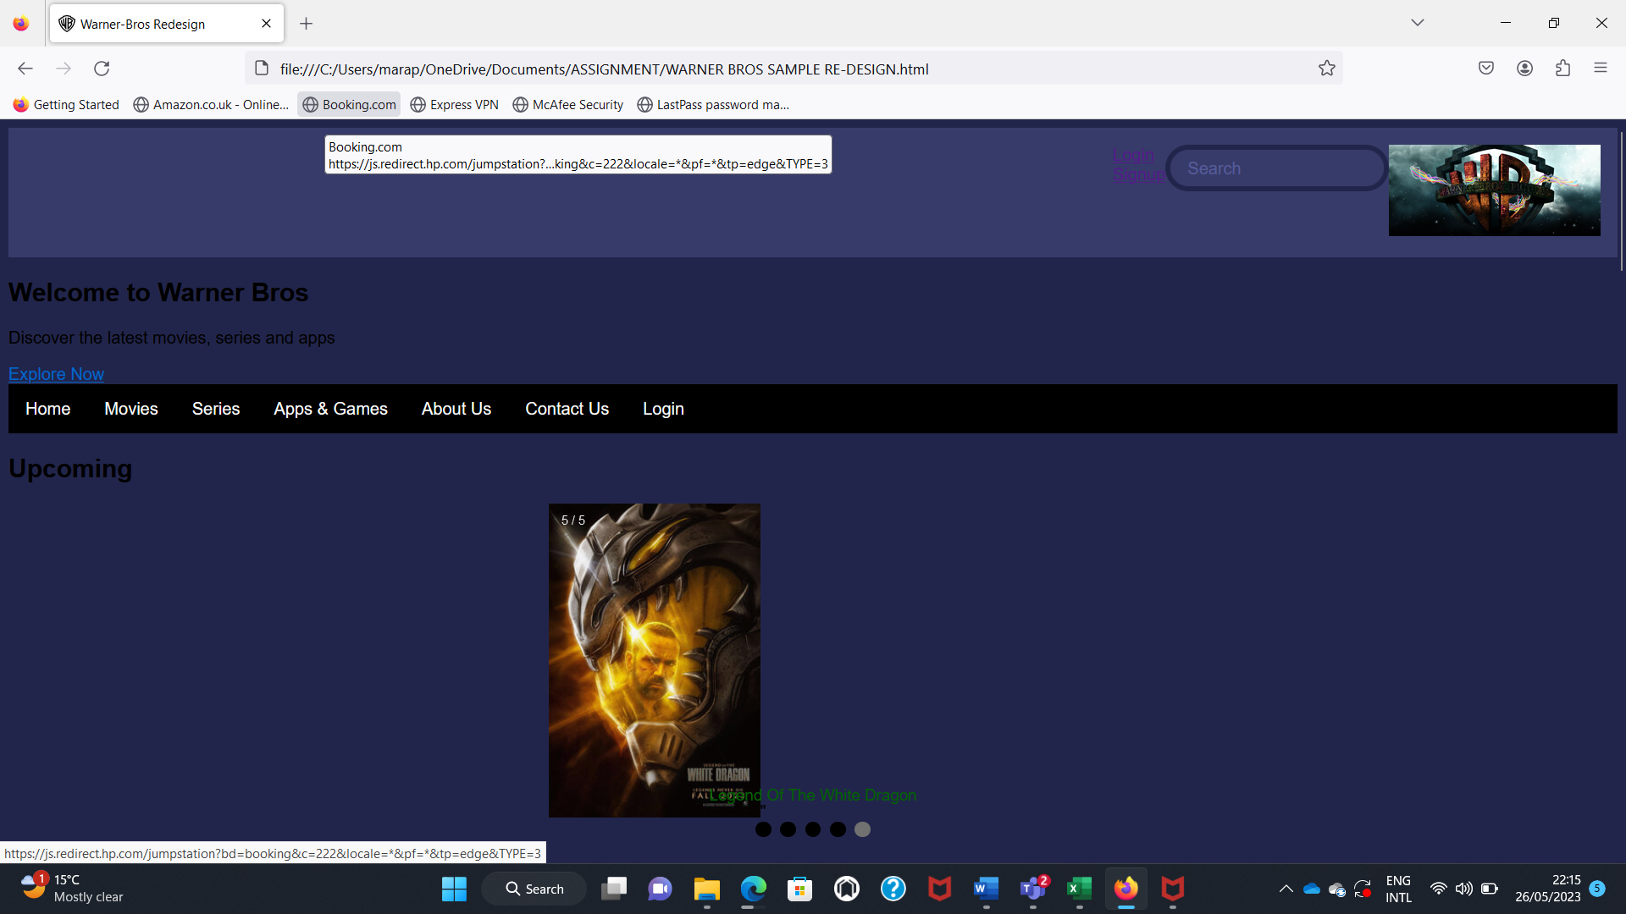

6.Publition & Promotion

The website is hosted on a platform called **GitHub** which is an online platform that hosts software projects and allows developers to share, collaborate, and review code in various programming languages.

The following is a link to were one can find the website I created:

https://JoshuaMarapo.github.io/cse22-024/

7. Future development & recommendations

* The website could be made so that the speed and performance could be increased through compressing images as well as caching code minification, caching, thus ensuring fast loading times across all devices and browsers.
* The search function should be improved so that it enables advanced filtering options like allowing users to search by specific criteria such as genre, release year, cast, director.
* The website could be made so that social media platforms are added to enable easy sharing of movie trailers, news, and updates, instead of just using emails which people nowadays no longer use as much.